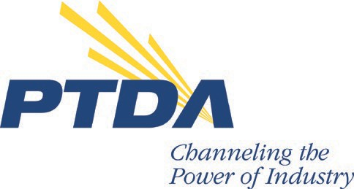

***Power Transmission Distributors Association*** *230 West Monroe Street Suite 1410*

*Chicago, IL 60606-4703 USA*

*Phone: +1.312.516.2100*

*Fax: +1.312.516.2101*

*E-mail:* [*ptda@ptda.org*](mailto:ptda@ptda.org)

[*www.ptda.org*](http://www.ptda.org/)***NEWS RELEASE***

*For more information, please contact:*

*Jennifer Busk*

[*jbusk@ptda.org*](mailto:jbusk@ptda.org)

*+1.773.716.3970*

**Chris Bursack, ISC Companies, Honored with PTDA Warren Pike Award**

*Chicago, Ill.*—*November 1, 2023—*The Power Transmission Distributors Association (PTDA) has named Chris Bursack the 32nd recipient of its Warren Pike Award for lifetime achievement in the power transmission/motion control (PT/MC) industry. He received the accolade during the PTDA 2023 Industry Summit on October 20 in Amelia Island, Fla.

Established in 1984, the Warren Pike Award honors individuals who have demonstrated outstanding, continuous, long-term support of PTDA and the PT/MC industry and is only presented when an individual’s achievements merit this prestigious recognition. Warren Pike Award recipients are selected by the PTDA Board of Directors.

Bursack spent most of his career in the PT/MC industry with ISC Companies, now a division of Weimer Bearing & Transmission. He’s known for his loyalty to his trade, peers and advancement of the industry. Through his involvement with PTDA, he’s been a member of at least seven task forces and committees and served on the PTDA Board of Directors, including as treasurer twice.

“People don’t know we are here but what we do is vital for virtually every aspect of modern life,” shared Bursack while accepting his award. “We work in the lumber industry—we house people. We work in the meat packing plant and the dairy—we feed people. We work in the pharmaceutical industry—we help people heal. We work in the printing industry—we help educate people. We work in the automotive industry—we transport people. To stand here today, as part of an industry as important as ours and to have my name listed with such an august group of leaders who have received the Warren Pike award, I am both incredibly honored and incredibly humbled.”

View Chris’s acceptance remarks and learn more about the Warren Pike Award at [ptda.org/WarrenPikeAward.](https://www.ptda.org/warrenpikeaward?viewmode=0)

The Power Transmission Distributors Association (PTDA) is the leading global association for the industrial power transmission/motion control (PT/MC) distribution channel. Headquartered in Chicago, PTDA represents power transmission/motion control distribution firms that generate more than $19 billion in sales and span over 2,700 locations. PTDA members also include manufacturers that supply the PT/MC industry.

PTDA is dedicated to providing exceptional networking, targeted education, relevant information and leading-edge business tools to help distributors and manufacturers meet marketplace demands competitively and profitably. For more information, call +1.312.516.2100, visit [ptda.org](http://www.ptda.org) or follow on [LinkedIn](https://www.linkedin.com/company/power-transmission-distributors-association) or Twitter at [@PTDAorg](https://twitter.com/ptdaorg).

# # #

*Photo caption: Chris Bursack, ISC Companies, receives the PTDA 2023 Warren Pike Award.*